Statistical Methods II

Multiple Linear Regression Project Report

Aiden Rader
4/25/2026

Introduction
Used car prices can vary a lot depending on factors like age, mileage, engine power, and overall condition. Roughly understanding how these variables influence price is important for both buyers and sellers, as well as for building predictive models that reflect real-world market behavior.
The purpose of this study is to analyze a dataset of used car listings and determine which factors significantly affect vehicle price. This analysis focuses on identifying the relationships between price and several explanatory variables, including model age, mileage (in kilometers), engine power (in Pferdestärke / ps), gearbox type (manual or automatic), damage status, and fuel type (including gasoline, diesel, hybrid, lpg, electric, cng, etc.).
This study uses multiple linear regression (MLR) to model the relationship between these variables and used car prices. MLR is appropriate in this context because it allows for the inclusion of both quantitative and categorical predicators, enabling a more comprehensive analysis of the factors that influence car prices.
It is important to note that this dataset is observational rather than experimental. Therefore, the results of this analysis identify associations between variables but do not establish causal relationships.

Dataset & Variables
  - Original Dataset
The dataset used in this analysis consists of used car listings obtained from eBay Kleinanzeigen, a German online classifieds platform, and were made publicly available on Data.World (Koehne, 2016). The data was collected through web scraping by the organization data-society. The listings were collected between March and April of 2016 and were originally recorded in German with variable translation (not data translated).
The original dataset contains many observations and variables describing various aspects of used vehicles, including price, mileage, engine power, and condition. Each observation represents a single used car listing.
At this stage, the dataset had not yet been cleaned or processed. It contained several issues typical of real-world data sets, including irrelevant variables, inconsistent formatting, and potentially unrealistic values. For example, the dataset included variables such as listing identifiers and timestamps, which were not relevant to the modeling objective.
The primary variable of interest is price (later changed to price_euros), which represents the listed price of each vehicle in euros. Several additional variables were considered as potential predictors of price, including mileage (km), engine power (ps), vehicle age (derived later as model_age), gearbox type, and damage status. Additional variables such as fuel type, vehicle type, and brand were also present in the original dataset and evaluated during later stages of the analysis.
This original dataset serves as the starting point for the data validation and cleaning process, which is necessary to prepare the data for meaningful statistical analysis.
  - Data Validation
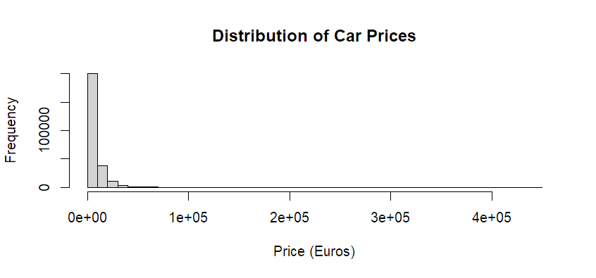
Before performing any statistical analysis, the original dataset was carefully examined to identify potential issues that could affect the accuracy and reliability of the results. Because the data was collected through web scraping, it contained several inconsistencies and irregularities typical of real-world datasets. The skewness of the raw price distribution is illustrated in Figure 1. Most observations are concentrated at lower price values, while a small number of extremely high prices create a long right tail.
Figure 1: Distribution of raw vehicle prices before cleaning.
In addition to the skewed distribution of price, further inspection of the dataset revealed the presence of extreme values and potential outliers in several variables, including mileage (km) and engine power (ps). Some listings contained unusually high or low values that were not consistent with typical vehicle data, suggesting possible data entry errors or incomplete listings.
The dataset also contained inconsistencies in categorical variables. Because the data was originally recorded in German, certain categories required interpretation and standardization. In some cases, missing or ambiguous entries were present, particularly in variables such as gearbox type and damage status.
Additionally, several variables in the original dataset were not relevant to the goals of this analysis. These included identifiers, timestamps, and other metadata that do not contribute to predicting vehicle price. Retaining these variables would add unnecessary complexity without improving the model.
Overall, this validation process confirmed that the dataset contained several issues, including skewness, outliers, inconsistencies, and irrelevant variables. These findings highlighted the need for data cleaning and transformation before proceeding with regression modeling.
  - Data Cleaning
Based on the issues identified during the validation process, several data cleaning steps were performed to prepare the dataset for analysis. These steps focused on removing irrelevant variables, addressing inconsistencies, and transforming variables to improve their suitability for multiple regression modeling. A visual overview of the data cleaning pipeline is provided in Appendix A.
First, variables that were not relevant to the analysis were removed. These included identifiers, timestamps, and other metadata that do not contribute to predicting vehicle price. Removing these variables simplified the dataset and allowed the analysis to focus only on meaningful predictors.
Next, extreme values and unrealistic observations were addressed. Observations with implausible values for variables such as price, mileage (km), and engine power (ps) were removed or filtered to reduce the impact of outliers. This step was important to ensure that the regression model would not be overly influenced by inaccurate or non-representative data points.
In addition, categorical variables were cleaned and standardized. Because the dataset was originally recorded in German, variable labels and categories were translated and simplified to ensure consistency. Missing or ambiguous entries in variables such as gearbox (transmission type) and not_repaired_damage (if the vehicle has damage or not) were handled appropriately to maintain data quality.
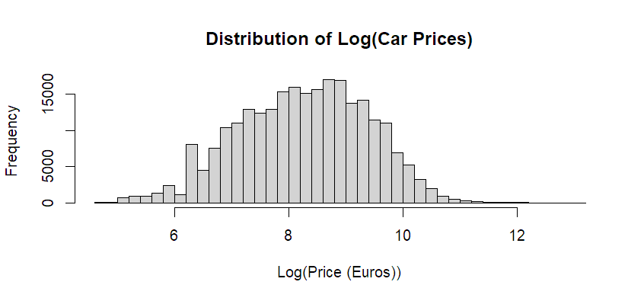
One of the most important transformations applied during data cleaning was the logarithmic transformation of the price variable. As shown in Figure 1, the original price distribution was highly right skewed. To address this issue, a new variable, log_price, was created using the natural logarithm of price. As shown in Figure 2, this transformation reduces the influence of extreme values and produces a more symmetric distribution, making it more appropriate for multiple linear regression analysis.
Figure 2: Log Distribution of car prices using R histogram.
Finally, a new variable, model_age, was created to represent the age of each vehicle. This variable was derived from the model year and provides a more interpretable measure for analysis. Using model age instead of model year improves the interpretability of regression coefficients.
After completing these steps, the dataset was transformed into a clean and structured format suitable for exploratory data analysis and multiple linear regression modeling.

Explanatory Data Analysis (EDA)
  - Following data cleaning, exploratory data analysis (EDA) was conducted to better understand the relationships between the response variable and the explanatory variables. Both quantitative and categorical variables were examined using graphical methods to identify trends, patterns, and relationships that could inform the regression model.
  - Continuous Variables
Scatterplots were constructed to examine the relationships between the transformed response variable, log_price, and each of the quantitative predictors.
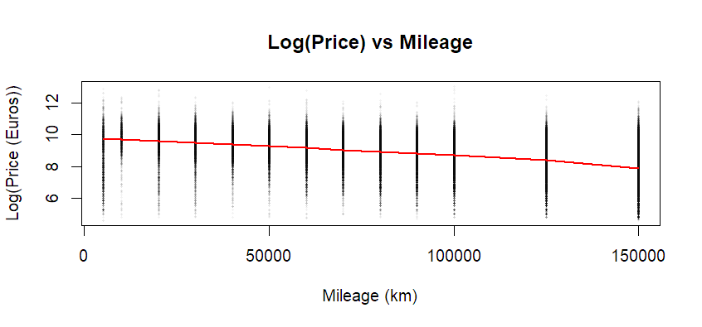
As shown in Figure 3, the relationship between log_price and mileage (km) exhibits a negative trend (trend line created using LOWESS smoothing), indicating that vehicles with higher mileage tend to have lower prices. The pattern suggests a decreasing relationship, although the spread of points shows that the relationship is not perfectly linear. The vertical grouping in the plot is likely due to the large number of observations and the fact that mileage values are recorded as whole numbers.
Figure 3: Log-transformed price vs. mileage (km), showing a negative relationship.
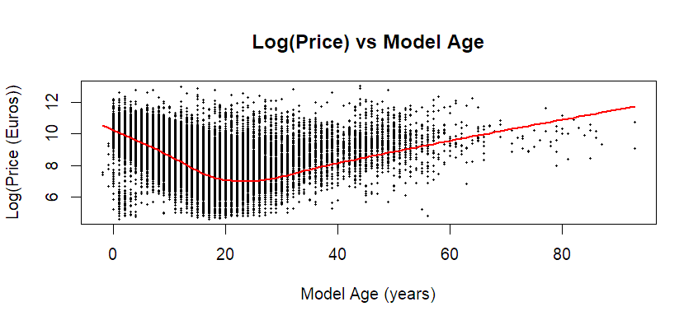
Similarly, the relationship between log_price and model_age (Figure 4) shows a negative association, where older vehicles tend to have lower prices. This relationship appears slightly curved (trend line created using LOWESS smoothing), suggesting that the rate of price decline is not constant across all ages. One possible explanation is that some older vehicles may retain or increase value due to rarity or collector interest.
Figure 4: Log-transformed price vs. model age (years), showing a negative relationship with slight nonlinearity.
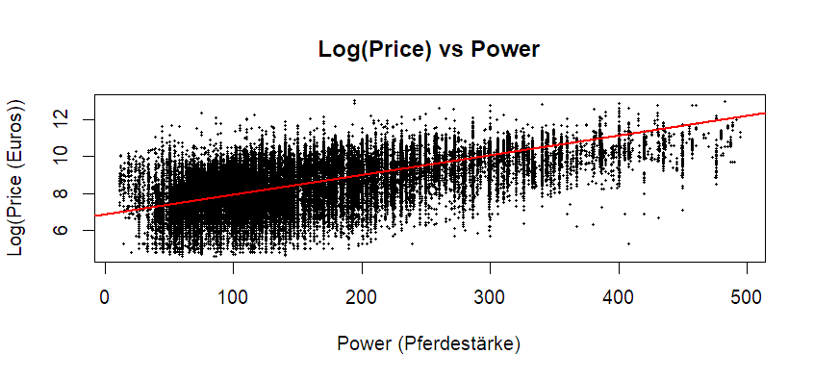
In contrast, the relationship between log_price and engine power (ps) (Figure 5) shows a positive trend (linear trend line created). Vehicles with greater engine power tend to have higher prices, although there is still noticeable variability in the data.
Figure 5: Log-transformed price vs. engine power (ps), showing a positive relationship.
Overall, these scatterplots indicate that mileage and age are negatively associated with price, while engine power is positively associated with price. While clear trends are present, the relationships are not perfectly linear, which supports the use of multiple regression to model these variables simultaneously.
  - Categorical Variables
Categorical variables were examined using boxplots to compare the distribution of log_price across different groups.
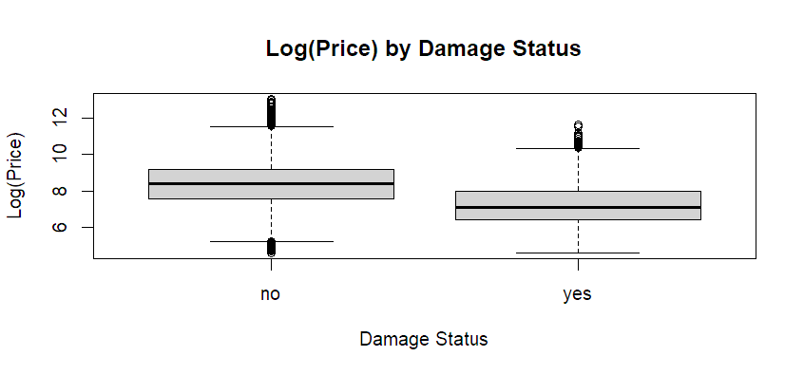
As shown in Figure 6, vehicles with unrepaired damage have noticeably lower prices compared to those without damage. The separation between the distributions suggests that damage status is an important factor influencing price.
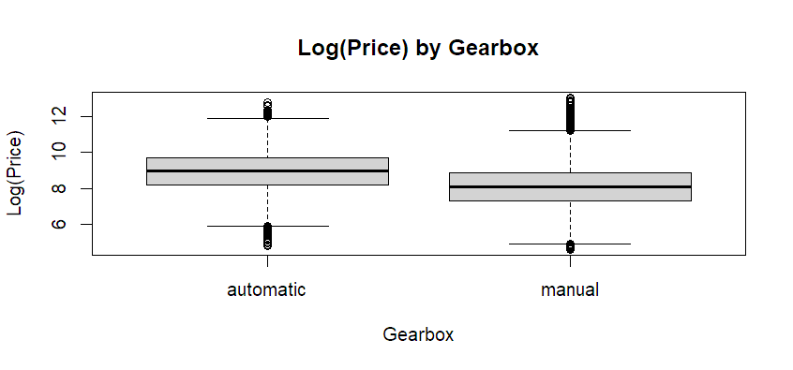
Similarly, the boxplot for gearbox (Figure 7) shows differences between transmission types. Vehicles with automatic transmissions tend to have slightly higher prices than those with manual transmissions, although the difference is less pronounced compared to the effect of damage.
Figure 6: Categorical boxplot given if a vehicle is damaged or not, made with R boxplot.
These results suggest that categorical variables such as damage status and gearbox type provide useful information and should be included in the regression model.
Figure 7: Categorical boxplot given a vehicles transmission type, made with R boxplot.

Correlation Analysis
 | log_price | model_age | km | ps
log_price | 1.000 | -0.568 | -0.446 | 0.565
model_age | -0.568 | 1.000 | 0.388 | -0.203
km | -0.446 | 0.388 | 1.000 | -0.016
ps | 0.565 | -0.203 | -0.016 | 1.000
To further examine the relationships between variables, a correlation matrix was computed for the continuous variables included in the analysis. The results are shown in Table 1.
The correlation between log_price and model_age is moderately negative (-0.568), indicating that older vehicles tend to have lower prices.
Table 1: Correlation matrix for log-transformed price and continuous predictor variables
Similarly, log_price and mileage (km) show a negative correlation (-0.446), suggesting that vehicles with higher mileage are generally less expensive. These findings are consistent with the patterns observed in the scatterplots.
In contrast, log_price and engine power (ps) exhibit a moderate positive correlation (0.565), indicating that vehicles with greater engine power tend to have higher prices. This relationship also aligns with the positive trend observed in the EDA.
The correlation between model_age and mileage is positive (0.388), which is expected, as older vehicles tend to have accumulated more mileage over time. However, engine power (ps) shows little to no correlation with mileage (-0.016), suggesting that engine power is largely independent of how much a vehicle has been driven.
Overall, these results suggest that there is no strong multicollinearity among the predictors, supporting their inclusion in the multiple linear regression model.

Model Testing & Selection
  - Multiple Regression Models
To model the relationship between vehicle price and the selected explanatory variables, a multiple linear regression framework was used with the transformed response variable, log_price.
To identify an appropriate model, several regression models were constructed using a stepwise approach. The modeling process began with a baseline model consisting of only the continuous variables (model_age, mileage (km), and engine power (ps)). Additional models were then developed by progressively introducing categorical variables such as gearbox, not_repaired_damage, fuel_type, vehicle_type (reduced), and brand (grouped).
Model performance was evaluated using $R^{2}$, adjusted $R^{2}$, and statistical significance of the predictors. This iterative process allowed for comparison between simpler and more complex models to balance explanatory power and interpretability.
Based on this process, two models emerged as strong candidates: Model 3.5, which includes gearbox and damage status, and Model 4, which additionally incorporates fuel type. While Model 4 achieved the highest $R^{2}$, it also introduced additional complexity. Therefore, both models were considered in the evaluation, with the final model selected based on overall performance and interpretability.
  - Model Estimation & Fitted Equation
The regression models were estimated in R using the lm() function. Summary output for the two strongest models, Model 3.5 and Model 4, is presented below. Summary results for the remaining models are included in Appendix B.
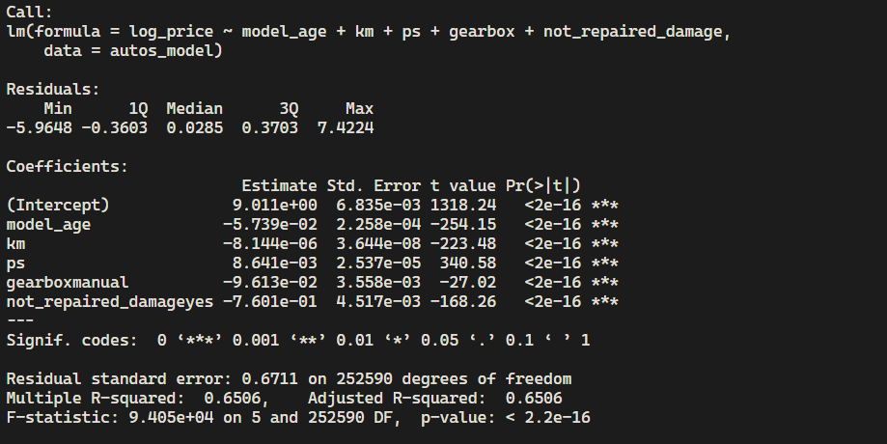
Model 3.5 includes both gearbox and not_repaired_damage in addition to the continuous predictors. As shown in Figure 8, all variables in this model are statistically significant, and the model achieves an $R^{2}$ of ~0.651, indicating that about 65.1% of the variability in log-transformed price is explained by the predictors.
Figure 8: Summary output for Model 3.5, including coefficient estimates, standard errors, and overall model fit statistics.
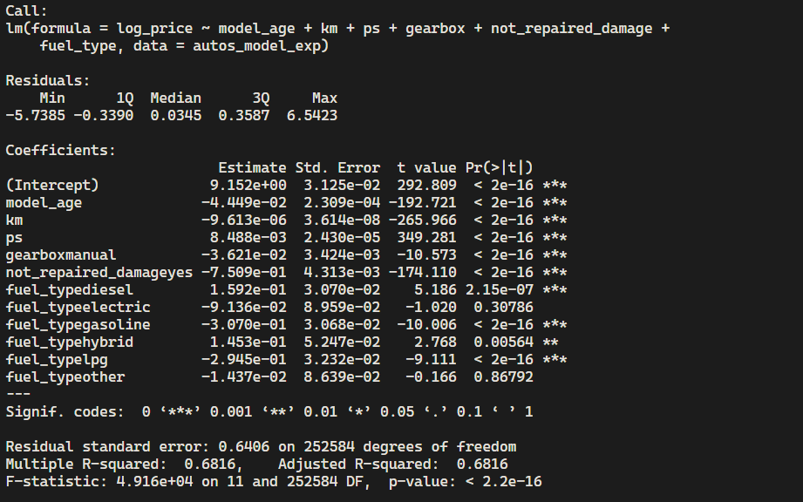
Model 4 extends Model 3.5 by including fuel_type, resulting in the highest observed$R^{2}$ of ~0.682. As shown in Figure 9, this indicates that approximately 68.2% of the variation in log-transformed vehicle price is explained by the model. However, not all fuel type categories are statistically significant, suggesting that the additional complexity does not uniformly improve the model.
Figure 9: Summary output for Model 4, showing coefficient estimates and improved model fit compared to Model 3.5.
  - Fitted Regression Equation
Despite the increased complexity, Model 4 was selected as the final model due to its higher explanatory power. The population multiple regression model is given by:
$$\log\left(price\right)= β_{0}+β_{1}\left(model_age\right)+β_{2}\left(km\right)+β_{3}\left(ps\right)+ β_{4}(gearbox)+ β_{5}(not_repaired_damage)+ β_{6}(fuel_type)+ε$$
Equation 1: Final population regression equation for Model 4
The fitted regression equation based on Model 4 is:
$$\hat{\log\left(price\right)= }9.152-0.04449\left(model_age\right)-0.000009613\left(km\right)+0.008488\left(ps\right)-0.03621\left({gearbox}_{manual}\right)-0.7509\left({not_repaired_damage}_{yes}\right)+0.1592\left({fuel_type}_{diesel}\right)-0.09136\left({fuel_type}_{electric}\right)-0.03070\left({fuel_type}_{gasoline}\right)+0.1453\left({fuel_type}_{hybrid}\right)-0.02945\left({fuel_type}_{lpg}\right)-0.01437({fuel_type}_{other})$$
Equation 2: Final fitted regression equation for Model 4
Note: Categorical variables are represented using indicator (dummy) variables, and each coefficient is interpreted relative to a reference category.

Coefficient Interpretation
The estimated coefficients from Model 4 provide insight into how each variable influences vehicle price, holding all other variables constant. Remembering the response variable is log-transformed, coefficients can be interpreted as approximate percentage changes in price.
  - Continuous Variables
The coefficient for model_age is negative (-0.0445), indicating that, on average, each additional year of age is associated with approximately a 4.4% decrease in price, holding other variables constant.
Similarly, mileage (km) has a negative coefficient (-0.00000961), suggesting that vehicles with higher mileage tend to have lower prices. For example, an increase of 10,000 km is associated with approximately a 9.6% decrease in price.
In contrast, engine power (ps) has a positive coefficient (+0.00849), indicating that more powerful vehicles tend to have higher prices. An increase of 10 horsepower is associated with approximately an 8.5% increase in price.

  - Categorical Variables
The coefficient for not_repaired_damage is strongly negative (-0.7509), indicating that vehicles with unrepaired damage are associated with substantially lower prices. Specifically, vehicles with damage are estimated to have approximately a 53% lower price compared to similar vehicles without damage.
The coefficient for gearbox (manual) is negative (-0.0362), suggesting that manual transmission vehicles are priced slightly lower than automatic vehicles, with an estimated decrease of approximately 3.6%.
The inclusion of fuel_type reveals differences across vehicle categories. Diesel (+0.159) and hybrid (+0.145) vehicles are associated with higher prices, corresponding to approximately 17% and 16% increases, respectively, compared to the reference category.
Gasoline (-0.0307) and LPG (-0.0295) vehicles show small negative effects, corresponding to approximately 3% lower prices.
The coefficient for electric vehicles and other fuel types is not statistically significant, suggesting that there is no clear difference in price relative to the reference category.
  - Overview
Overall, the results indicate that vehicle age, mileage, and damage status have the strongest negative effects on price, while engine power and certain fuel types contribute to higher prices. Among all predictors, damage status appears to have the largest impact, highlighting its importance in determining vehicle value.

Model Diagnostics
To evaluate whether the assumptions of the multiple regression model are satisfied, several diagnostic plots were examined, including a residuals vs fitted values plot, a normal Q-Q plot, and a histogram of residuals.
  - Residuals vs Fitted Values
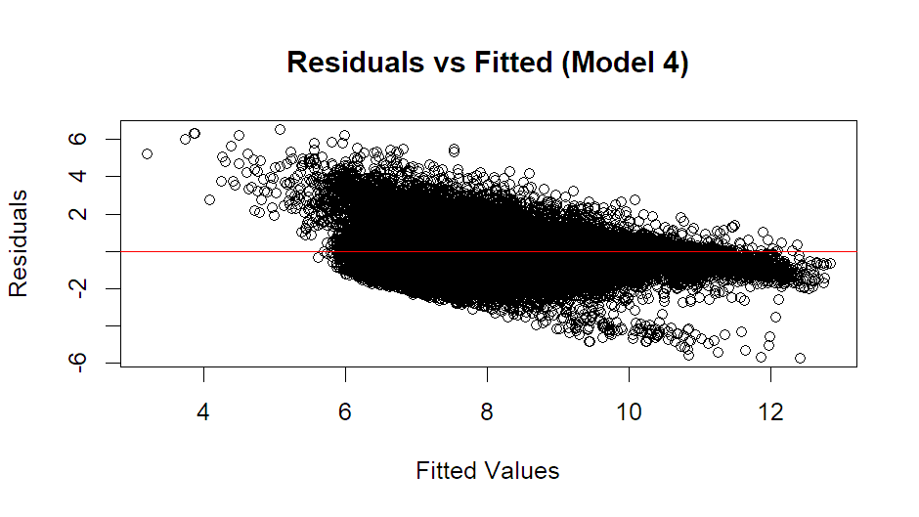
The residuals vs fitted values plot (Figure 10) shows that the residuals are generally centered around zero, which supports the assumption of linearity. However, there is some noticeable change in the spread of residuals across fitted values, with a wider spread at lower fitted values and a narrower spread at higher fitted values. This pattern suggests the mild presence of heteroscedasticity, indicating non-constant variance in the residuals across all levels of the tested model.
Figure 10: Residuals vs fitted values for Model 4. Residuals are centered around zero, with some change in spread across fitted values, suggesting mild heteroscedasticity.
  - Normal Q-Q Plot
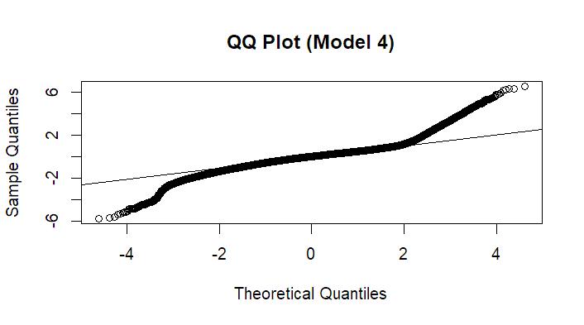
The normal Q-Q plot (Figure 11) indicates that the residuals are approximately normally distributed, as most points lie close to the reference line. However, there are some deviations at the extreme ends of the distribution, suggesting the presence of outliers or heavier tails than expected under perfect normality.
Figure 11: Normal Q-Q plot of residuals for Model 4. Residuals are approximately normally distributed, with slight deviations in the tails.
  - Residual Histogram
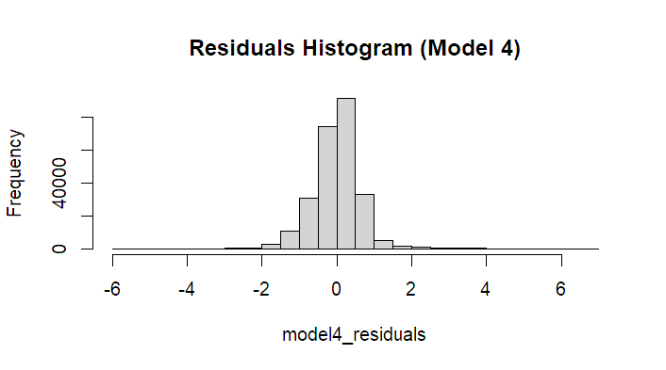
The histogram of residuals (Figure 12) appears roughly symmetric and centered around zero, which further supports the assumption of approximate normality. Minor deviations from symmetry are present but are not severe.
Figure 12: Histogram of residuals for Model 4. The distribution appears roughly symmetric and centered around zero, supporting approximate normality.

Hypothesis Testing
To evaluate the statistical significance of the regression model and its predictors, both an overall F-test and individual t-tests were conducted.
  - Overall Model Significance (F-Test)
To determine whether the regression model provides a meaningful explanation of vehicle price, an overall F-test was conducted.
Hypothesis:
$$H_{0}: β_{1}=β_{2}=…=β_{6}=0$$
$$H_{a}:At least one β_{i}≠0$$
Putting this into words, the null hypothesis states that none of the predictor variables have a relationship with vehicle price, meaning that all regression coefficients are equal to zero. The alternative hypothesis states that at least one predictor variable has a relationship with vehicle price, meaning that at least one regression coefficient is not equal to zero.
Test Statistic:
From the model summary output (as seen is Figure 9):
- $F=4.916×{10}^{4}$
- Degrees of freedom: $df_{1}=11, df_{2}=252,584$
- p-value < $2.2×{10}^{-16}$
Conclusion:
Because the p-value is extremely small (less than 0.05), we reject the null hypothesis. This indicates that the regression model is statistically significant and that at least one predictor variable is related to vehicle price.
  - Individual Predictor Significance (t-tests)
To evaluate the contribution of each predictor, individual t-tests were performed for each regression coefficient.
Hypotheses (for each predictor):
$$H_{0}: β_{i}=0$$
$$H_{a}:β_{i}≠0$$
In other words, the null hypothesis states that the predictor has no relationship with the vehicle price, while the alternative means that there is some sort of relationship between the vehicle price and the predictor.
Results & Interpretation:
Most predictors in the model, including model_age, km, ps, gearbox, and not_repaired_damage, have extremely small p-values (less than 0.05), indicating that they are statistically significant predictors of vehicle price.
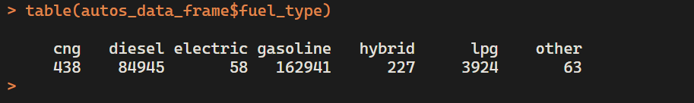
Among the fuel type variables, diesel, gasoline, hybrid, and lpg are statistically significant. However, electric and other fuel types (i.e. cng, other) are not statistically significant, suggesting that these categories do not have a clear effect on price relative to the reference category.
Figure 13: R output of entry counts for each category of fuel type.
Interestingly, although cng has more observations than hybrid, it is not statistically significant, while hybrid is (as shown in Figure 13). This indicates statistical significance is not solely determined by sample size, but rather by the strength and consistency of the relationship between the predictor and the response variable. This may also indicate that hybrid vehicles have a more consistent pricing pattern compared to cng vehicles.
Conclusion:
Overall, many predictors in the model are statistically significant, supporting their inclusion in the regression model. The presence of non-significant variables suggests that some predictors may not meaningfully contribute to explaining variation in vehicle price.

Conclusion / Summary
In this analysis, a multiple linear regression model was developed to examine the factors that influence used vehicle prices. Using a dataset of vehicle listings, several continuous and categorical variables were explored through data cleaning, exploratory data analysis, and regression modeling.
The results indicate that vehicle age, mileage, and damage status are among the key factors affecting price, all showing strong negative relationships. Vehicles with unrepaired damage were associated with substantially lower prices, making damage status one of the most influential predictors in the model.
On the other hand, engine power and certain fuel types, such as diesel and hybrid, were associated with higher prices. These findings suggest that both performance-related characteristics and vehicle condition play key roles in determining vehicle value.
The final model (Model 4) achieved an $R^{2}$ of ~0.682, indicating that about 68.2% of the variability in log-transformed vehicle price is explained by the predictors included in the model. While this represents a strong fit, diagnostic analysis revealed minor deviations from model assumptions, including slight non-constant variance and departures from normality at extreme values.
Overall, the model provides a meaningful and reasonably accurate representation of the factors that influence vehicle pricing. These results highlight the importance of both physical characteristics and condition-related variables when evaluating vehicle value and demonstrate how multiple regression can be used to analyze complex real-world datasets.
  - Limitations & Real-World Considerations
While Model 4 was our chosen final model due to its higher explanatory power, it is important to acknowledge several limitations. The inclusion of additional variables, such as fuel type, increases model complexity, and not all categories were statistically significant. This suggests while the model improves overall fitness, some predictors may not meaningfully contribute to explaining price.
Although multiple linear regression can be useful for prediction, in this case, predicting used vehicle prices is inherently challenging due to the nature of the market. The dataset consists primarily of listings from private sellers (~99%), where pricing can be highly subjective and influenced by factors not captured in the model, such as seller urgency, negotiation behavior, vehicle condition beyond reported variables, and local market dynamics.
As a result, while the model provides useful insights into general trends and relationships, it may not fully capture the variability present in real-world pricing. This highlights the difficulty of building a perfectly accurate predictive model in a complex and unpredictable market.

References
- Koehne, J. (2016, November 22). Used Cars Data - dataset by data-society. data.world. https://data.world/data-society/used-cars-data

Appendices

Appendix A: Data Cleaning and Preprocessing Pipeline
The following figure provides a visual summary of the data cleaning steps described in the report.

Figure A1: Overview of the data cleaning and preprocessing pipeline applied to the dataset.

Appendix B: Extra Model Summaries
The following summaries include additional regression models considered during the model selection process: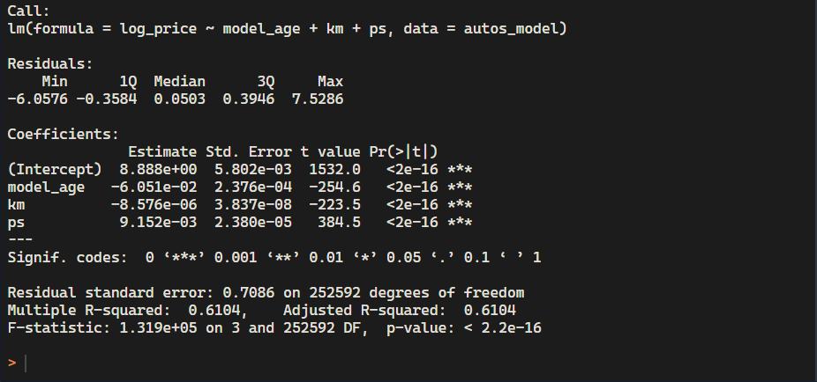
Figure B1: Model 1 (Baseline) summary statistics
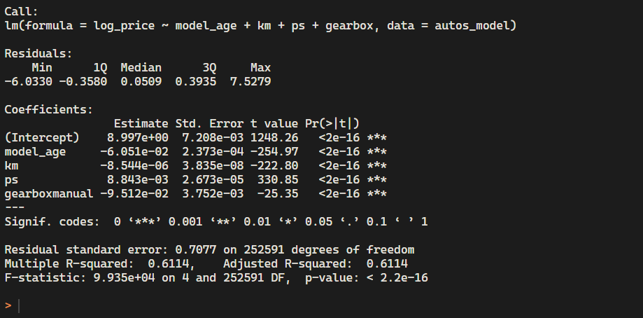
Figure B2: Model 2 summary statistics (adding gearbox variable)
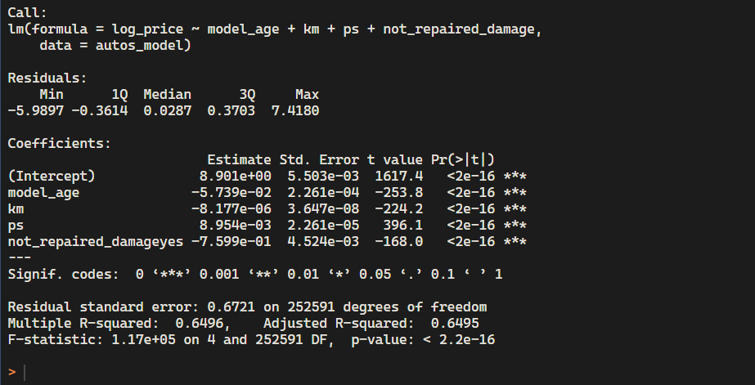
Figure B3: Model 3 summary statistics (adding not_repaired_damage variable)
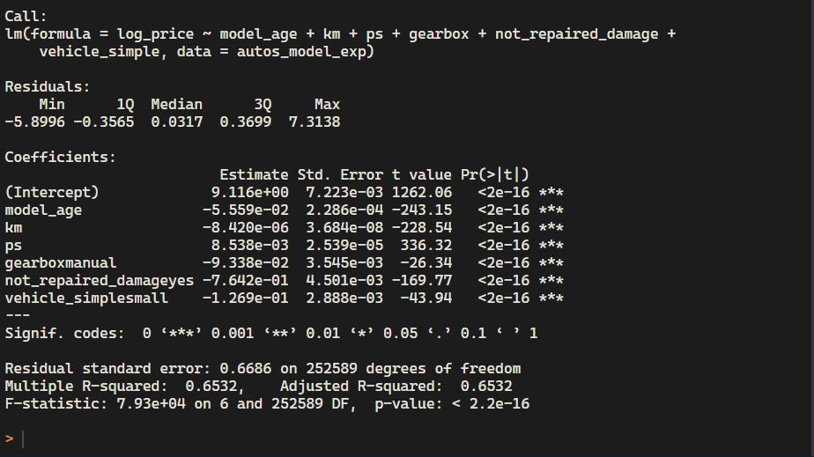
Figure B4: Model 5 summary statistics (adding grouped vehicle_simple variable)
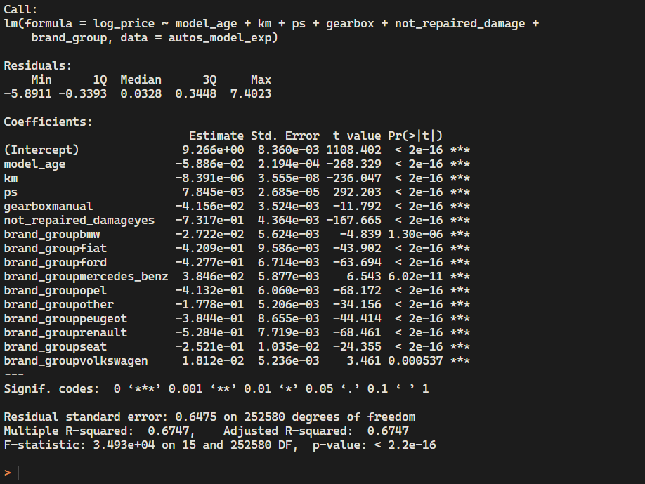
Figure B5:

